Snort Network Intrusion Detection System (NIDS)
Step1: write commands for update and installing snort

Sudo apt update & sudo apt install snort –y
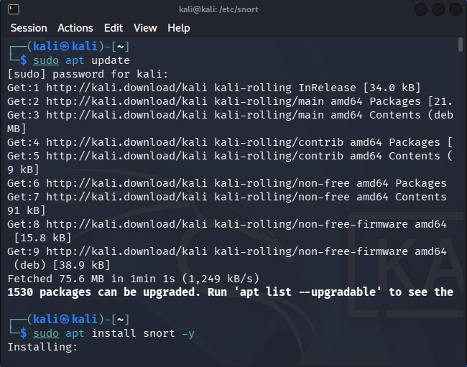

STEP2: First check your ethernet connection write
ip a
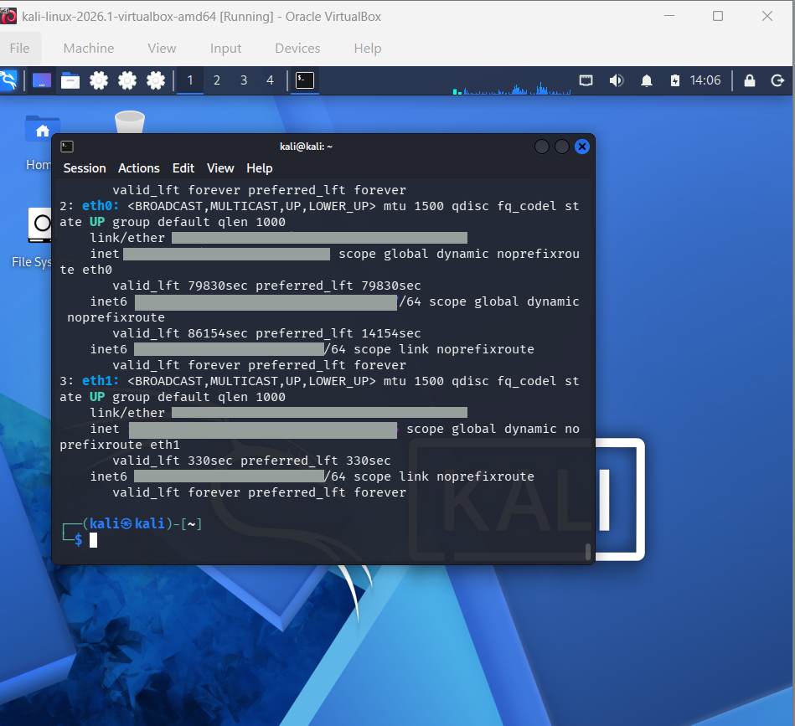

STEP3:
WRITE sudo nano /etc/snort/snort.lua ( IT WILL OPEN NANO EDITOR AS YOU CAN SEE IN THE IMGAE USE YOUR ARROW UP AND DOWN BUTTON AND CHANGE CONFIGURATION
Replace HOME_NET = 'any‘ • HOME_NET = ‘192.168.56.0/24'
DON’T CLOSE THIS EDITOR CHECK STEP 4 FIRST

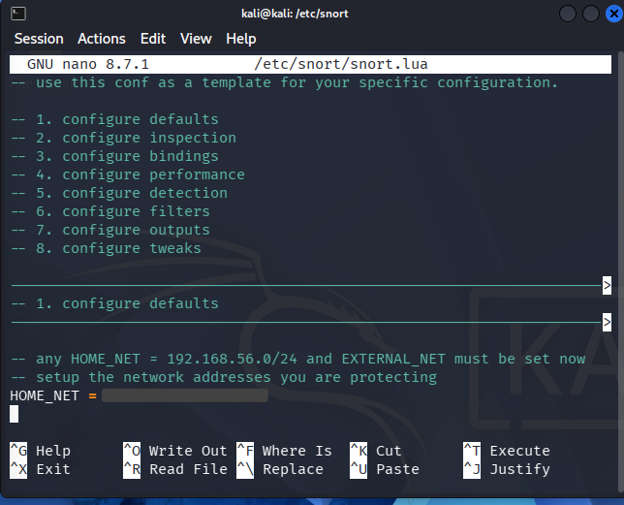

STEP4:
GO TO CONFIGURATION DETECTION AND RIGHT
ips =
{
rules = [[ include /etc/snort/rules/local.rules ]],

variables = default_variables
}
AFTER RIGHT THIS PRESS CTRL + O AND HIT ENTER THEN CTRL + X FOR EXIT

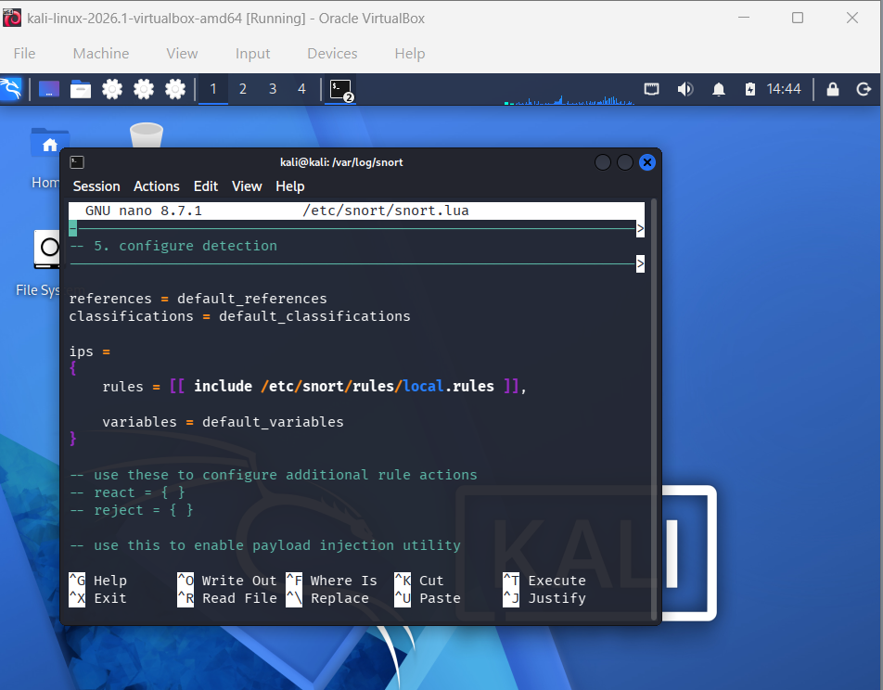

STEP5: WRITE sudo nano /etc/snort/rules/local.rules
Then add this rule:
alert icmp any any -> any any (msg:"ICMP TEST ALERT"; sid:1000001; rev:1;)
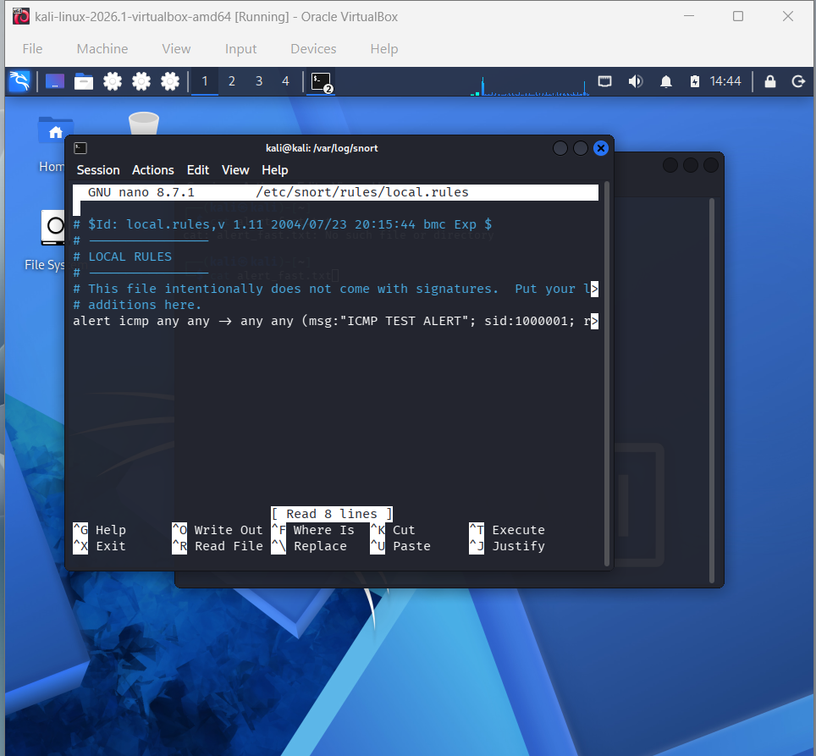

STEP 6: WIRTE sudo snort -T -c /etc/snort/snort.lua
Its shows you • Snort successfully validated the configuration
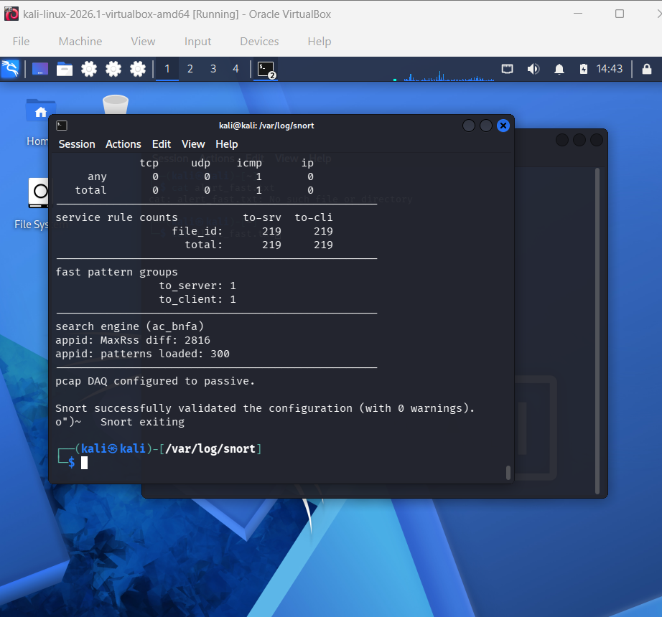

STEP 7: THEN WRITE THIS
sudo snort -c /etc/snort/snort.lua -i eth1 -A alert_fast
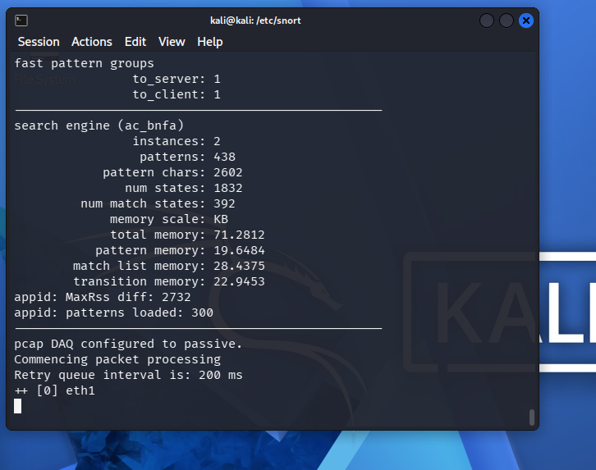

STEP 9:
OPEN cmd ON YOUR WINDOWS OPERATING SYSTEM BY PRESSING CTRL + R AND TYPE CMD OR SIMPLY YOU CAN SEARCH ON YOUR WINDOWS SEARCH BAR

THEN TYPE: Ping 192.168.56.x –t
( according to your Ethernet ip) for checking your eth ip type ip a
Then check your which eth has this ip 192.168.56.x/24
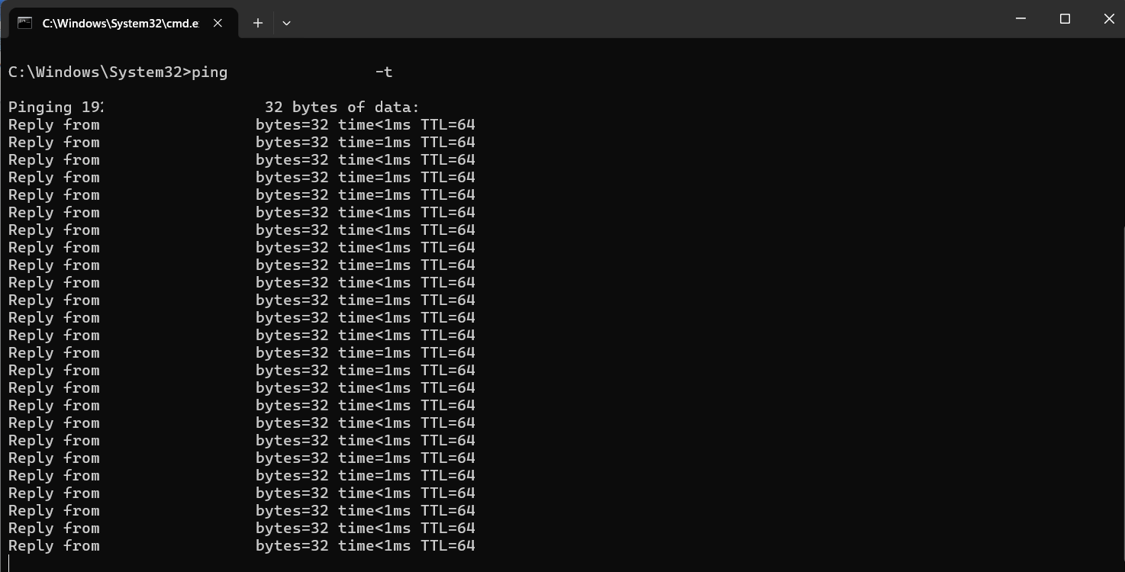

STEP 10: GO BACK ON YOUR LINUX ADMINISTRATION AND WATCH THIS (NIDS)
HOW SNORT WORKING THIS IS CALLED NETWORK INTRUSION DETECTION AS YOU CAN SEE
SNORT GENERATING REAL TIME ALERTS ON THIS GIVEN IMAGE
